Document Version: 2008.001

Dear TOP84PLC user,
when you get the screen message "Please ask your distributor for MODxxx..., a hardware change is necessary for that specific device you would like to program. This modification concerns some devices which require a fast pull-up or clock/oscillator on a special pin or do not have the supply-pins at the standard locations. Please refer to the schematic on page 2 of this document to locate the positions of the device- and requested modification-pins.
The required change is easy to do, just connect one of the enclosed cables between the programming socket pin and the requested modification pin (X51..X56, X81,X82 or X85..X94). If you have any problems do not hesitate to contact Data I/O.

1) Remove the TOP84PLC from your programmer.
2) Look for the schematics to locate the position of the programming socket- and the modification-pin
3) Connect the requested signal(s) with the programming socket-pin(s)
4) Replace the TOP84PLC on the programmer and start the programming software. The message "Please ask your distributor...." should no longer appear on the screen.

Note : Please use for VCC one of the three spare relays X54, X55 or X56
Please use for GND one of the three spare relays X51, X52 or X53
Please use for OSC one of the spare clocks X81, X82 or X90..X94

WARNING : It is not possible to have two different modifications in the same TOP84PLC, using the same signalresource (e.g. X51, X54 or X92). Only modifications using different signals can be installed in one TOP84PLC.

MOD | Device | Signal | Pin-number
21/97 | DALLAS  DS87C530 | OSC | 40 (Socket)
6/00 | TI  TMS430P325 FN | VCC | 14 (Socket)
3/02 | Motorola MC68HC705V8 | GND  GND  CLK | 3 (socket)  39 (socket)  6 (socket)
4/06 | (ZIL) Z16F2810VH | CLK | 30 (socket)
4/08 | (HIT) HD647180Z PLCC-84 | VCC  VCC | 5 (socket)  37(socket)

Location of the
modification pins

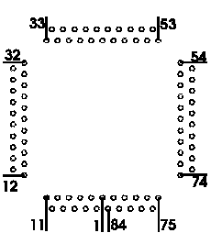

Pinlocation of the
programming socket

